Lab 6: Updating and Deleting Data

Objective
To update an existing product and delete a product using Entity Framework Core.

Commands Used
dotnet run

Code
Category.cs
using System.Collections.Generic;
namespace RetailInventory.Models
{
public class Category
{
public int Id { get; set; }
public string Name { get; set; }
public List<Product> Products { get; set; } = new List<Product>();
}}
Product.cs
namespace RetailInventory.Models
{ public class Product
{
public int Id { get; set; }
public string Name { get; set; }
public decimal Price { get; set; }
public int CategoryId { get; set; }
public Category Category { get; set; }
}
}
AppDbContext.cs
using Microsoft.EntityFrameworkCore;
using RetailInventory.Models;
namespace RetailInventory.Data
{
public class AppDbContext : DbContext
{ public DbSet<Product> Products { get; set; }
public DbSet<Category> Categories { get; set; }
protected override void OnConfiguring(DbContextOptionsBuilder optionsBuilder)
{ optionsBuilder.UseSqlServer(
"Server=localhost\\SQLEXPRESS;Database=RetailDB;Trusted_Connection=True;TrustServerCertificate=True;");
}
}

Program.cs

using RetailInventory.Data;

using var context = new AppDbContext();

var product = context.Products.FirstOrDefault(p => p.Id == 1);

if (product != null)

{

product.Price = 80000;

context.SaveChanges();

Console.WriteLine("Product updated successfully.");

}

var deleteProduct = context.Products.FirstOrDefault(p => p.Id == 2);

if (deleteProduct != null)

{

context.Products.Remove(deleteProduct);

context.SaveChanges();

Console.WriteLine("Product deleted successfully.");
}

Output
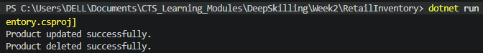
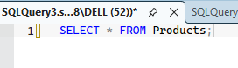
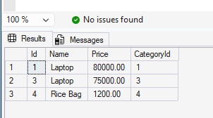

Result
The product records were filtered successfully using LINQ queries in Entity Framework Core.

